Individual Assignment Virtual Reality in the Workplace
By P L; Group Members:
October 30th, 2019


Generation Z and Virtual Reality in the Workplace
Generation Z
As Generation Z grows, develops, and enters the workforce, it is important for employers to start considering how to engage this group as well as how to ensure that they work effectively in their respective fields. For employers to do this, they must first learn about Generation Z’s values. It is imperative that employers understand that Generation Z individuals are in love with and are extremely attached to technology. According to Laura Gayle (2019), the founder of Business Woman Guide, “Gen Zers are rarely seen without their smartphones or another connected gadget in hand” and “tech is automatically their ‘go-to’ solution.” This expresses that if employers want to get their Gen Z workers engaged and working effectively, they must come up with a technology related solution.
Virtual Reality
One tech-related solution or practice employers can seize upon is utilizing Virtual Reality to address safety and effectiveness in the workplace. Virtual Reality (VR) refers to technology that simulates real-life experiences. Companies can use this technology to simulate real life experiences that are relevant to the job in order to inform, train and prepare their employees. Specifically, they can use VR equipment to train workers in preparation for the unexpected. This could then lead to employees performing effectively when they experience similar situations in real life. Additionally, VR could help with on-the-job training through which employees can learn important job skills that will normally take longer to acquire. Furthermore, it allows workers to practice and learn without being endangered.
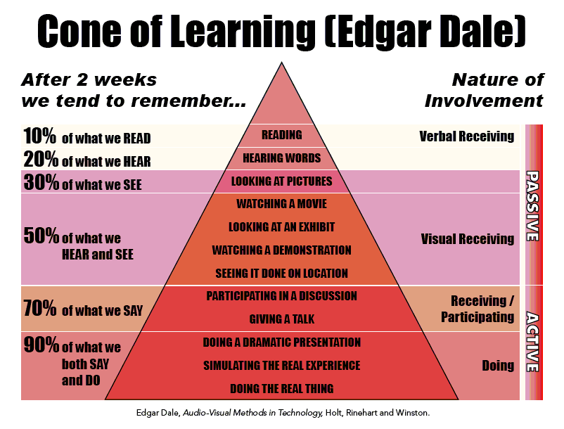

Successful Implementation of Virtual Reality Technology
Implementing VR at Stanford Medicine
To implement this practice, Companies simply need to create a space for the virtual reality lab, obtain the virtual reality technology, and design the simulations that are relevant to the company. Since several organizations are using the technology to train their workers, it is clear that Virtual Reality is effective in increasing employee safety and effectiveness. These companies include Stanford Medicine, BP, Exxon Mobil, Walmart, KFC, and UPS. For instance, “Virtual Reality System,” (n.d.) expresses that Stanford Medicine uses a “software system that combines imaging from MRIs, CT scans and angiograms to create a three-dimensional model that physicians...can see and manipulate...like a virtual reality game.” Stanford Medicine is implementing the use of VR systems by incorporating imaging performed on people into the software design in order to have an accurate depiction of the human body. This will then help residents perform surgeries. The organization states that “ VR system is helping train residents, assist surgeons in planning upcoming operations and educate patients” (“Virtual Reality System,” n.d.). In the medical field, residents usually learn over time by experiencing real surgeries, practicing on the deceased and doing real surgeries. With the VR system, residents can now effectively assist during surgeries because they are able to practice surgeries and practice dealing with complications that may arise during surgery. As a result they can begin to develop skills that would have taken them years to acquire.
Implementing VR at BP
Similarly, BP and Exxon Mobil, which are oil and gas industry corporations, are using virtual reality to address safety in the workplace. Working with oil and gas exposes employees to many dangers. As a result, it is important for employees in this industry to be equipped with knowledge of what to do in times of danger. VR is also helping employees in this industry to work more effectively. According to BP (n.d.), by “using state-of-the-art facilities...BP staff and contractors can simulate the specific conditions of a drilling operation, including the same rocks, temperatures and pressures...in order to replicate critical jobs on the rig.” BP expresses that Virtual Reality recreates the exact conditions that their employees and contractors have to work under. As a result, by practicing in simulations, employees are prepared to work safely and effectively under those conditions in real life. The company’s manager also mentions that its workers are building “...‘muscle memory to handle...emergencies’” (BP, n.d.). This demonstrates that BP is successfully implementing VR because the technology is actually helping its employees train and prepare for unexpected accidents. By using VR, BP has found a way to empower their workers to work more effectively.
Implementing VR at ExxonMobil
In comparison Exxon Mobil is successfully implementing VR by building a digital garage where employees can undergo safety training to prevent deaths on the job. The company expresses that “Immersive simulations can transport VR users onto the loading dock of a liquefied natural gas (LNG) tanker, where they spend a day on the job assessing and reacting to different scenarios, from the mundane to the complex” (“Safety Training,” 2019). ExxonMobil has built simulations where employees will deal with typical operations that occur within the job as well as challenging scenarios that can take place within the job. Therefore, employees will be armed and ready to face any obstacles that may arise on the job.

References

Cone of Learning. Ways of Retaining What is Learned. Reprinted from Medium, n.d., Retrieved from https://medium.com/@InstaVR/use-case-examples-of-virtual-reality-vr-training-2e2172e19fa4.
How Generation Z Is Transforming the Workplace. (n.d.). Retrieved October 30, 2019, from https://www.financialexecutives.org/FEI-Daily/August-2019/How-Generation-Z-Is-Transforming-the-Workplace.aspx.
Safety Training Gets a Dose of Virtual Reality. (2019, April 30). Retrieved October 30, 2019, from https://energyfactor.exxonmobil.com/science-technology/digital-garage-safety-training/.
Using VR for Employee Training: Here Are Real-world Examples! (2019, July 25). Retrieved October 30, 2019, from https://www.viar360.com/companies-using-virtual-reality-employee-training/.
Virtual Reality Prepares Drilling Teams for Real-life Challenges. (n.d.). Retrieved October 30, 2019, from https://www.bp.com/en/global/corporate/sustainability/safety/case-studies/virtual-reality-prepares-drilling-teams-for-real-life-challenges.html.
Virtual Reality System Helps Surgeons, Reassures Patients. (n.d.). Retrieved October 30, 2019, from https://medicalgiving.stanford.edu/news/virtual-reality-system-helps-surgeons-reassures-patients.html.

